Date: 9/20/2023

Team Number: 7

Links: Ex:

Non-team Members consulted: None

Reference Websites:

<https://www.geeksforgeeks.org/what-is-high-level-design-learn-system-design/>

Progress By Team Member:

Luke Pepin - High Level Application (see page 2), Research on Git Repo for next week

Kevin Sarango - Use Case Diagram (see page 3)

Richard Vega - Sequence Diagram (see page 4)

High Level Design:

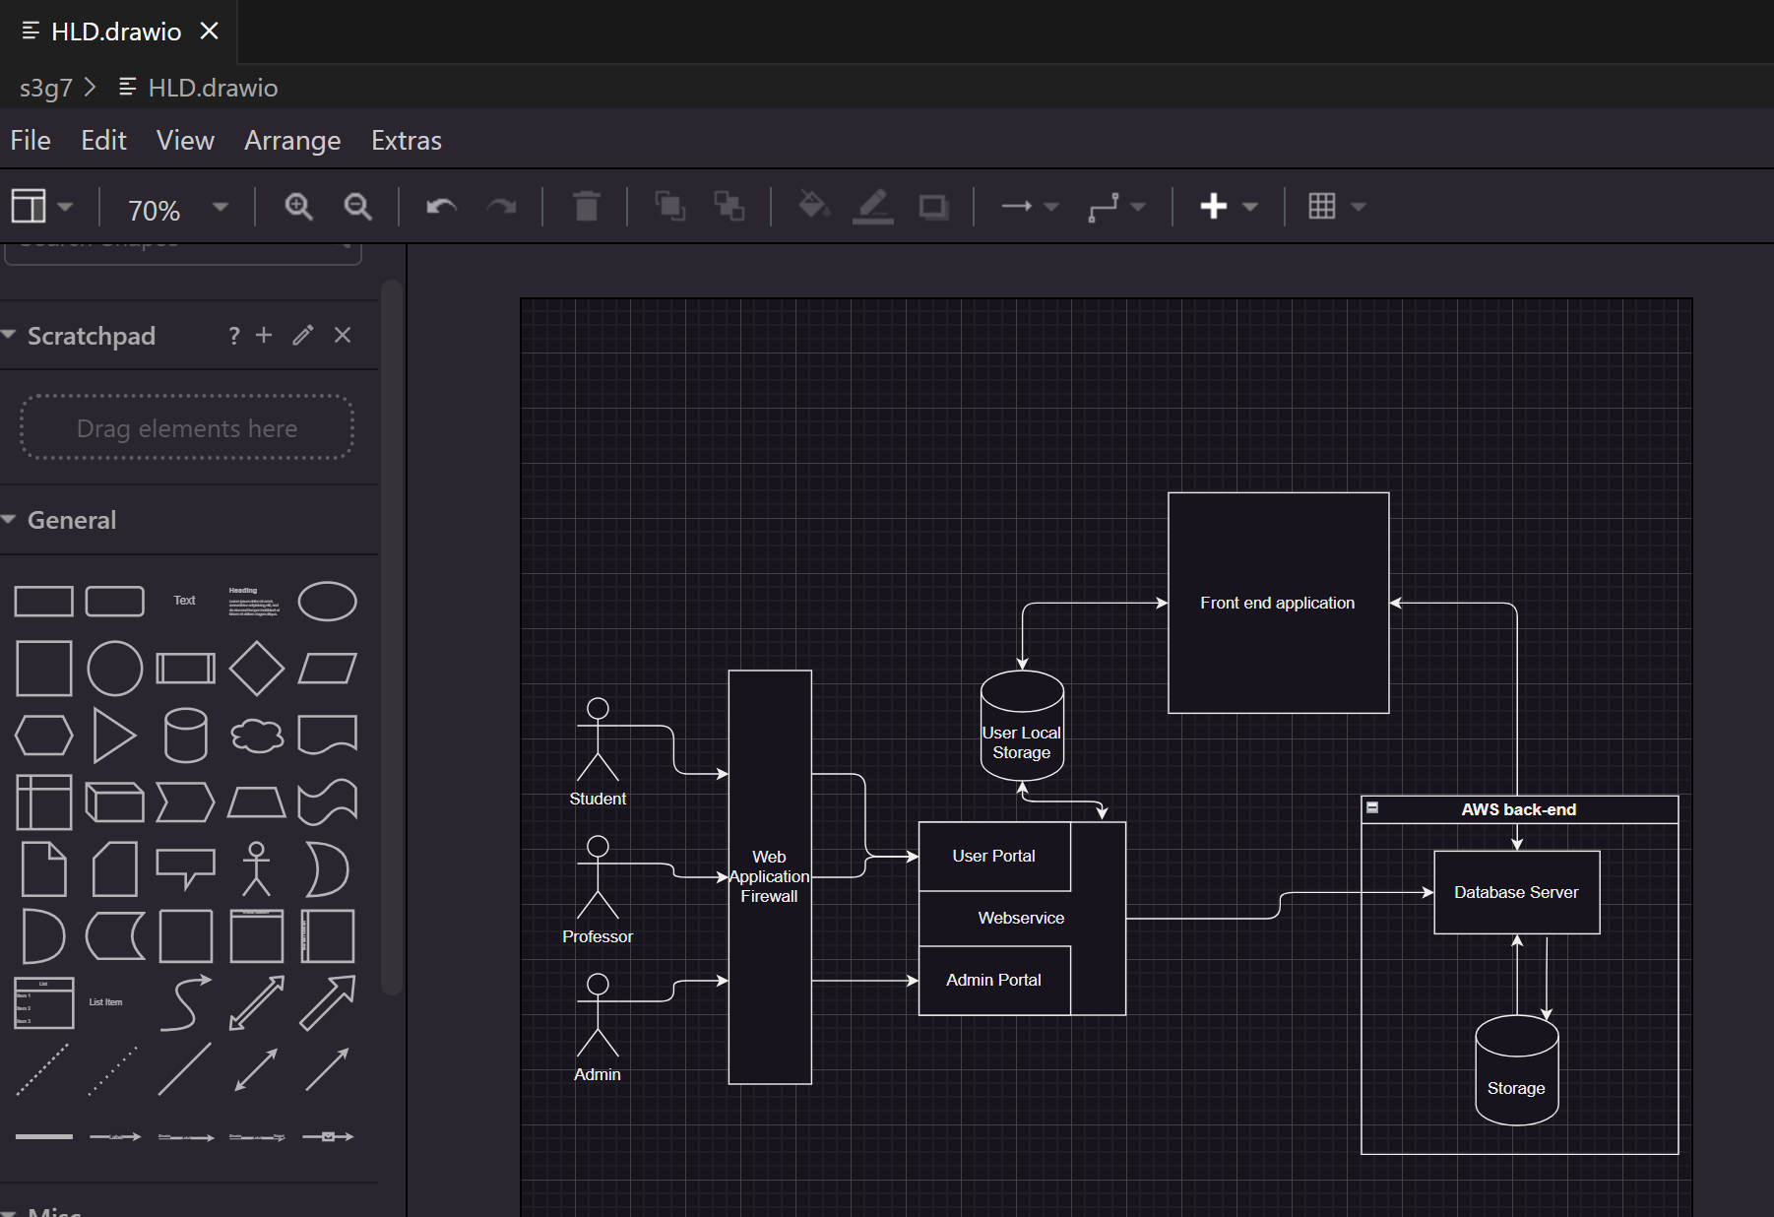

Use Case Diagram:

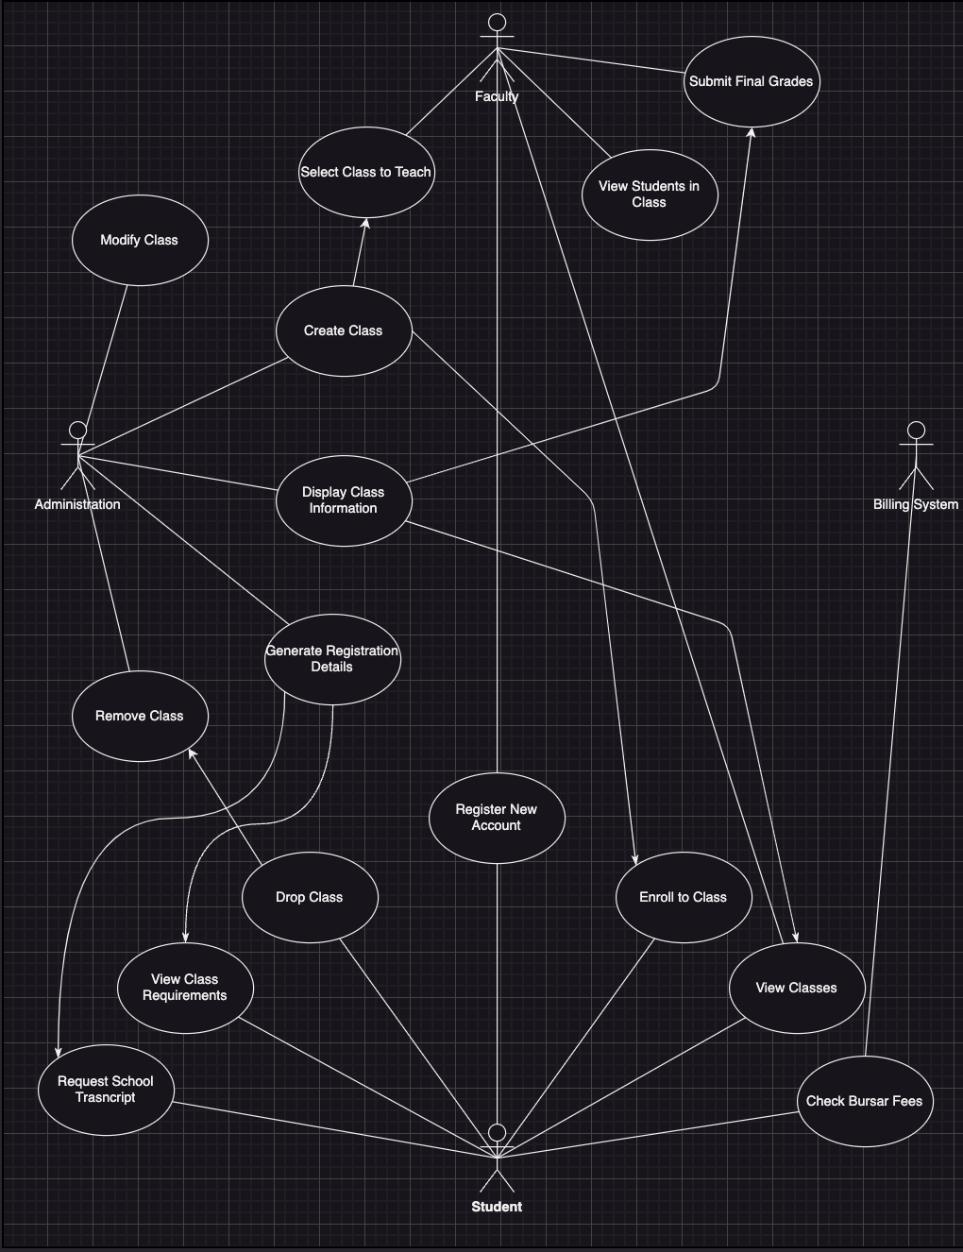

Class enrollment sequence diagram: